VIETNAM NATIONAL UNIVERSITY – HO CHI MINH CITY

UNIVERSITY OF SCIENCE

FACULTY OF INFORMATION TECHNOLOGY



**CSC14003 – AI PROJECT**

**WUMPUS WORLD**

LECTURER: Mr. Le Ngoc Thanh

Mrs. Ho Thi Thanh Tuyen

GROUP MEMBERS:

Trần Minh Đức 18127027

Nguyễn Vũ Thu Hiền 18127004

Đinh Phi Long 18127263

Ho Chi Minh City, 8/2020

**MỤC LỤC**

I. INTRODUCTION 3

1. ABSTRACT 3

2. ENVIRONMENT 4

3. ASSIGNMENT PLAN 4

II. APPROACH SOLVE PROBLEM 5

III. GAME STRUCTURE 6

IV. GUILD TO USE 7

V. RESULT AND MEASURE 8

# I. INTRODUCTION

## 1. ABSTRACT

The purpose of this project is to design and implement a *logical search agent* for a partially-observable environment. This will be accomplished by implementing an agent that navigates through the Wumpus World.

It is a game with:

* 2D cave connected by passages.
* Some rooms contain a pit into which we fall and perish.
  + We feel a breeze if near a pit.
* One room contains a Wumpus that will eat us.
  + We have one arrow that we can shoot in the direction we are facing.
  + We smell a stench if near the Wumpus.
* Somewhere, there is a pot of gold.
* We can move forward or backward, turn left by 90 degrees or right by 90 degrees.
* Find gold (if possible) and try and kill the Wumpus.

**Wumpus World**

* The world will be limited in 10x10. Room (1, 1) will still be the bottom-left one, and Room (10, 10) the top-right one. First number is room position in horizontal coordinate and second number is room position in vertical coordinate.
* Agent can appear in any Room (xa , ya) and always facing to the right. This room is the only room have the cave door.
* There may be any number of pits and gold in the world.
* There is at least one Wumpus.
* The agent carries an infinite number of arrows.
* The game will end when one of the following three conditions occurs:

1. The agent dies

2. The agent kills all of the Wumpus AND grabs all the gold

3. The agent climbs out of the cave

The **score** are as such:

* Add 100 points for picking up each gold.
* Reduce 100 points for shooting an arrow.
* Reduce 10000 points for dying (by being eaten by the Wumpus, falling in a pit).
* Add 10 point for climbing out of the cave.
* Reduce 10 points for moving from one room the the next.

## 2. ENVIRONMENT

- Language: Python 3.7+

- Graphic Game Framework: Pygame

- Enviroment Software: Anaconda

- Addition library: pytweening (optional)

- OS Build: Window 10 2004 (64 bits)

## 3. ROLE & ASSIGNMENT

|  |  |  |  |  |
| --- | --- | --- | --- | --- |
| **Milestone** | **Tasks** | **Date** | **Assigned to** | **Progress** |
| Base Game Structure | * Base game structure * Graphic display * Guild, rule to develop | 20/08/2020 | Đức | 100% |
| * Map parser, sample search implements base on map | 22/08/2020 | Đức | 100% |
| Implement problem | * Design assets | 22/08/2020 | Hiền | 100% |
| * Problem Analys | 22/08/2020 | Long, Hiền | 100% |
| * KB implement | 23/08/2020 | Đức | 100% |
| * Develop Algorithm & Implementations | 23/08/2020-24/08/2020 | Đức | 100% |
| * Unit test phase with small problem (4x4) | 24/08/2020 | Đức | 100% |
|  | * BFS to optimize path to a safe position | 24/08/2020 | Đức | 100% |
| Optimization | * Finished screen | 25/08/2020 | Hiền | 100% |
| * Optimize and release | 25/08/2020 | Đức | 100% |
| Test, Build Map, Report | * Test, Build Map, Report | 26/08/2020 | Hiền, Long | 100% |
| Report | * Algorithm + Result | 27/08/2020 | Long | 100% |
| * Others | 27/08/2020 | Hiền | 100% |

# II. APPROACH SOLVE PROBLEM

* Input: the given map is represented by matrix, which is stored in the input file, for example, map1.txt. The input file format is described as follows:

° The first line contains an integer N, which is the size of map.

° N next lines with each line represents a string. If room empty, it is marked by hyphen character (-). If room has some things or signal such as **W**umpus, **P**it, **B**reeze, **S**tench, or **A**gent, it is marked by first capitalized character in name of each type and written next to each other. Between two adjacent rooms is separated by a dot (.)

|  |  |  |  |  |  |  |  |  |  |
| --- | --- | --- | --- | --- | --- | --- | --- | --- | --- |
|  | BS | W | BS | P | B |  |  |  |  |

° This row is represented: -.BS.W.BS.P.B.-.-.-.-

* Output: a result with path for agent, game point will be displayed on screen and/or written in output text file such as result1.txt.

***ALGORITHM IDEA***

In the Knowledge base (KB), we have many lists to store things such as: the cells which are pits; the cells which are wumpus; the pit cells which are solved or not solved; the wumpus cells which are solved or not solved; the visited nodes and the safe nodes.

A cell is safe if and only if that cell does not contain a wumpus or a pit. If a cell has a stench sign then one of the adjacent cells must be wumpus. If a cell has a breeze sign then one of the adjacent cells must be pit. If a cell has both a breeze sign and a stench sign then the adjacent cells be wumpus or pit.

We have many tell() and ask() functions to help the agent check what the state of a cell is.

The agent start at (0, 0) then get all the adjacent cells it can move. Check the states of the cells and make the decision to choose the direction to move throughout perceive() function. If that cell contains a gold, the scores will increase 100 points.

The algorithm will open all the safe nodes ( the node that the agent infers is definitely safe). The games will end when all of the safe nodes are open.

# III. GAME STRUCTURE

** src**

* assets: The resources of this project, including fonts and images
* cores:

- kb_solve:

+ kb.py: KnowledgeBase

+ agent.py: Agent abstract

+ glu_agent.py: Glucose Agent ( base on glucose3 – referenced from HW)

- layout

+ parser.py: Read and process map from file

- search:

+ bfs.py: BFS algorithm to get the shortest path

- agent: necessary object to use in BFS algorithm. This structure base on LAB assignment 1 (search algorithm – 18127027)

- ui: solving graphic of each agent

- wumpus: solving wumpus, manage the title

* maps: including maps to test
* screens: contains EventScreen all screens object inherited from GameScreen.
* states: contains state of game (not playing)
* gpath.py: including global path in project
* setting.py: setting config for the game
* wumpus.py: main game

# IV. GUILD TO USE

- Open workspace at folder “***src***”

- Run “***wumpus.py***”

- Change map at “***maps/map_10_10.txt***”

- If you want to change map in file for tesing, please close and reopen the game.

- The implement is compatitve with any square size of map (4x4, 10x10,…). If you want to test, copy map to file maps/map_10_10.txt

# V. RESULT AND MEASURE

10 maps with maxium size is 10x10

* map1 (10x10)

Score : -930

Gold: 4

Step: 132

Safe nodes: 79

Position of all gold is:

[(3, 3), (4, 1), (8, 8), (2, 2)]

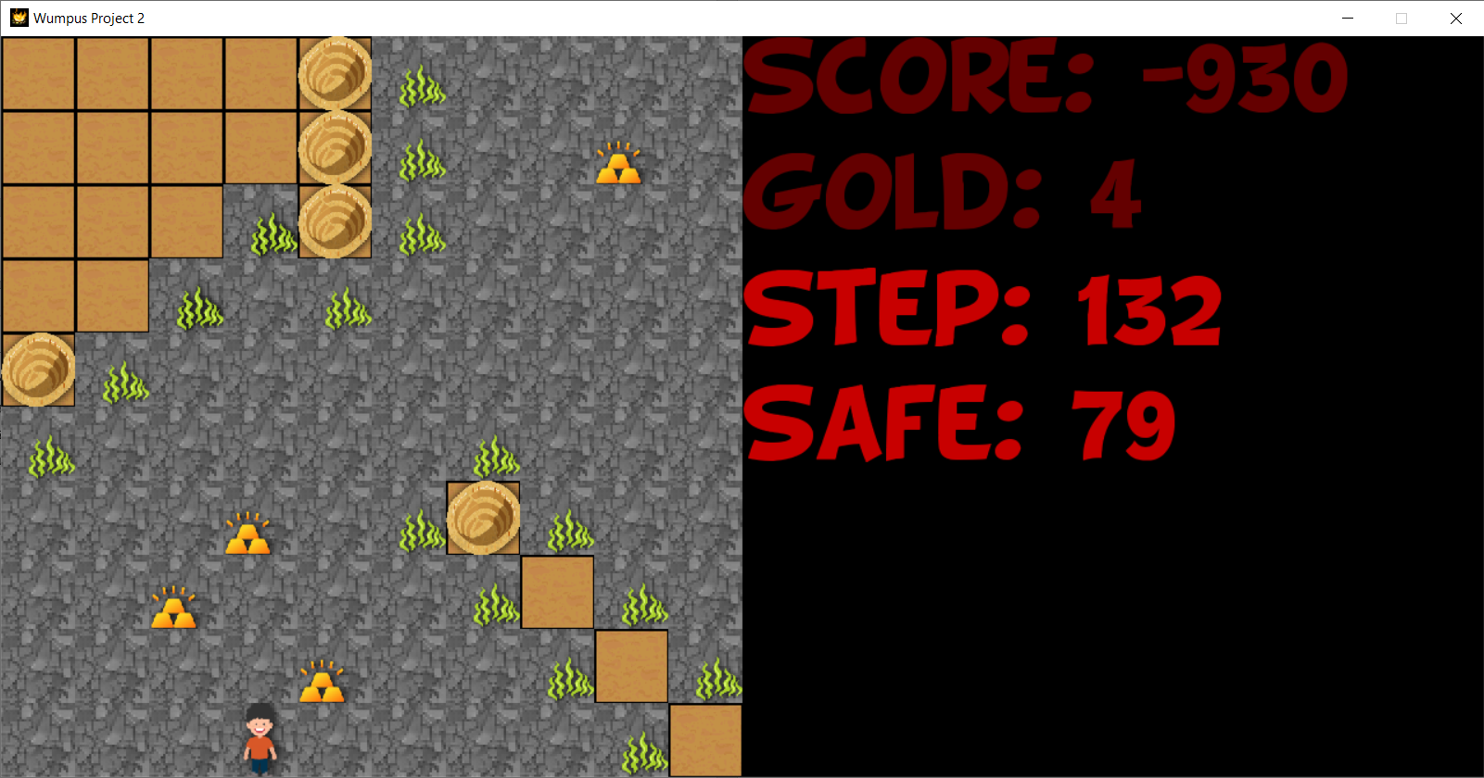

* map2 (4x4)

Score: 410

Gold: 12

Step: 78

Safe nodes: 40

Position of all gold is:

[(3, 5), (4, 1), (5, 1), (4, 5), (2, 3), (2, 1), (1, 0), (1, 1), (6, 1), (7, 1), (8, 1), (9, 0)]

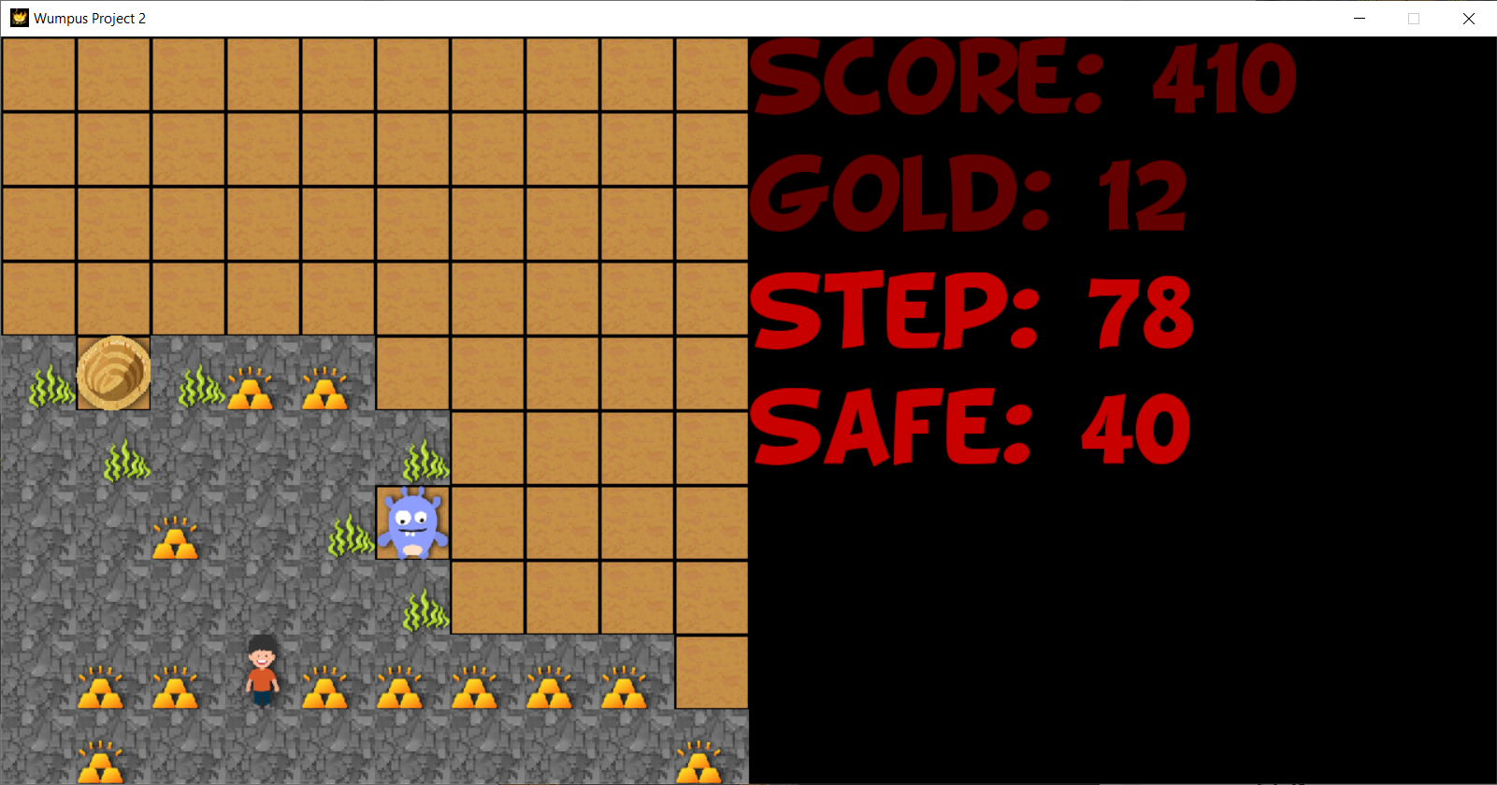

* map3

Score: -990

Gold: 5

Step: 148

Safe: 94

Position of all gold is:

[(0, 7), (2, 5), (1, 8), (4, 3), (8, 6)]

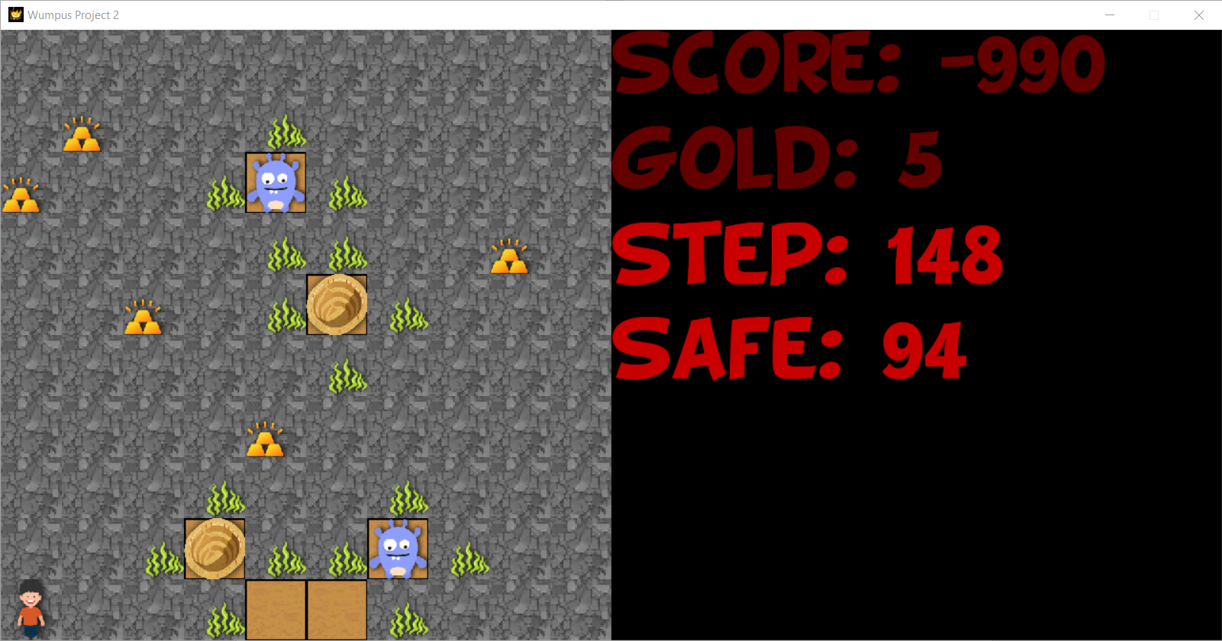

* map4

Score: -990

Gold: 6

Step: 148

Safe: 88

Position of all gold is:

[(0, 1), (1, 3), (3, 4), (5, 6), (3, 7), (4, 5)]

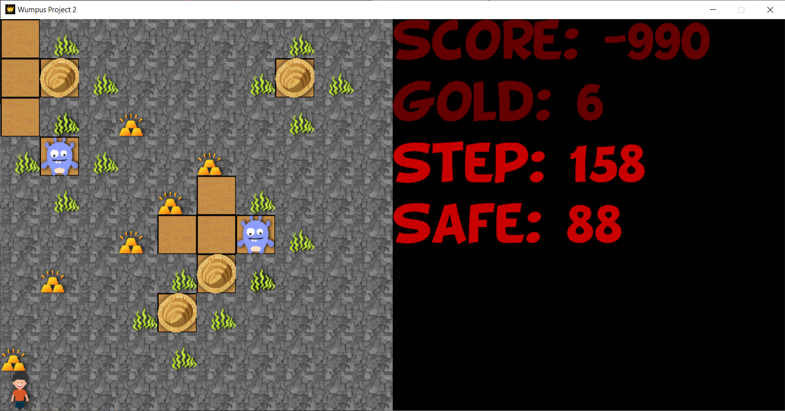

* map5

Score: -30

Gold: 14

Step: 142

Safe: 84

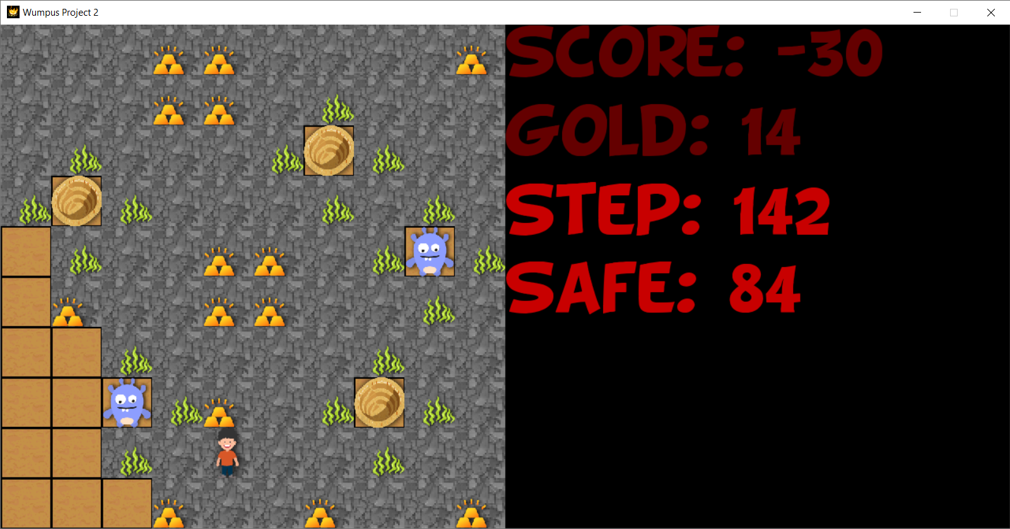

* map6

Score: 250

Gold: 17

Step: 144

Safe nodes: 89

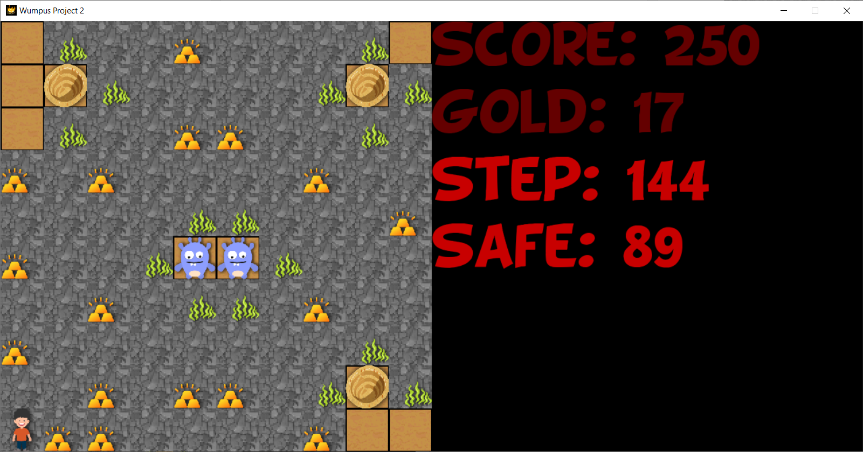

* map7

Score: 450

Gold: 14

Step: 94

Safe nodes: 57

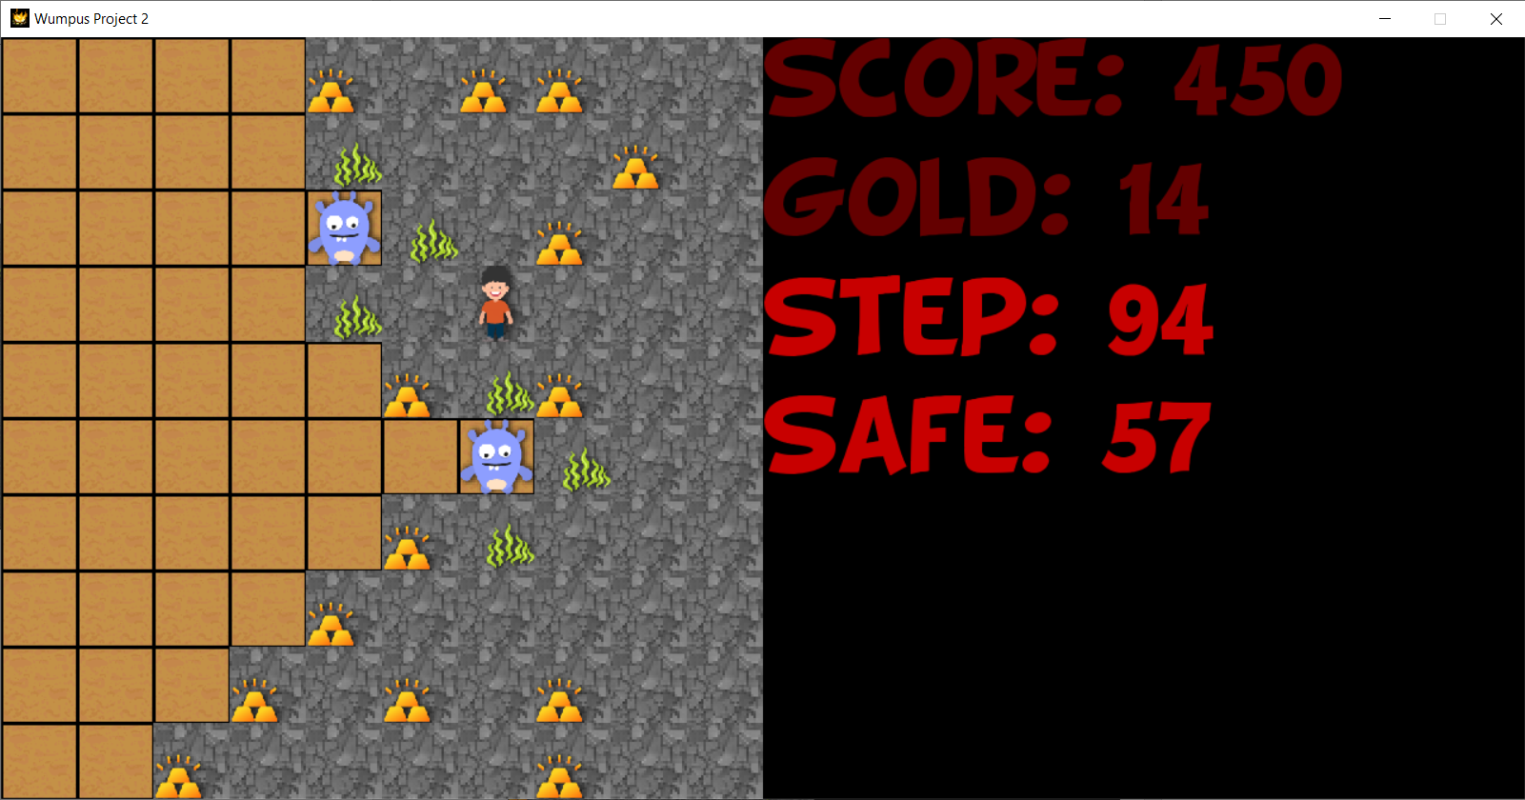

* map8

Score: -110

Gold: 14

Step: 160

Safe: 87

Position of all gold is:

[(7, 7), (8, 5), (8, 4), (8, 9), (9, 8), (9, 7), (5, 0), (4, 1), (3, 3), (3, 2), (4, 9), (1, 4), (2, 3), (1, 1), (3, 0)]

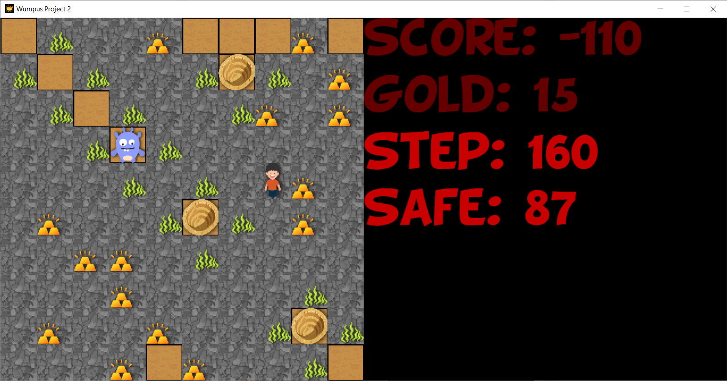

* map9

Score: 350

Gold: 10

Step: 64

Safe: 37

Position of all gold is:

[(4, 0), (2, 2), (2, 5), (1, 3), (1, 1), (1, 0), (5, 1), (6, 2), (6, 5), (0, 4)]

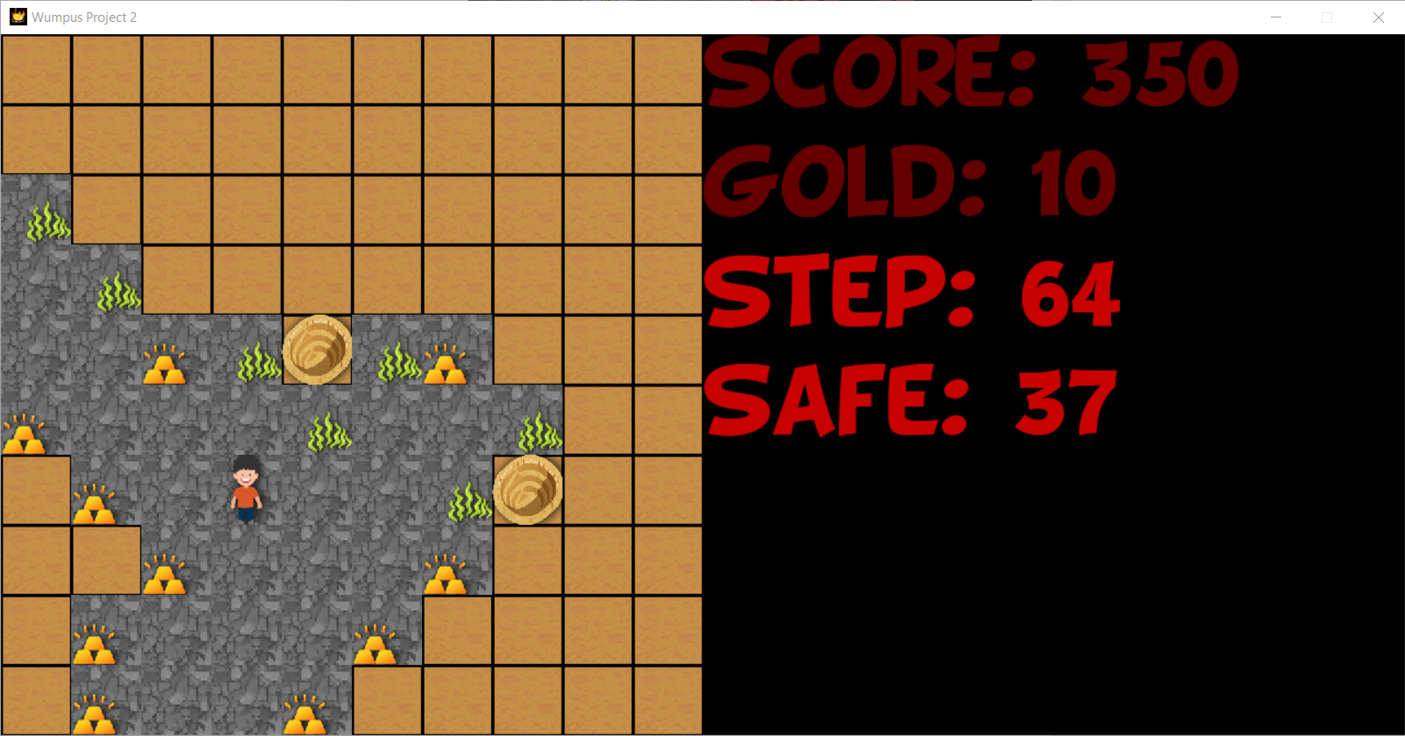

* map10

Score: 470

Gold: 8

Step: 32

Safe: 20

Position of all gold is:

[(1, 2), (3, 0), (3, 1), (2, 2), (1, 4), (2, 5), (3, 4), (3, 3)]

